1. Added Integral part. Duty was not going back to 0. Removed else condition.

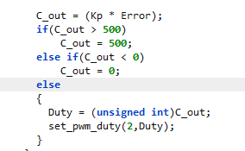

1. With 0.01 Integral, off set error is still there. For 200 it sits at 186-187. Increased Integral to .05
2. Added Integrator checker in timer interrupt. For some reason this doesn’t work outside of interrupt.

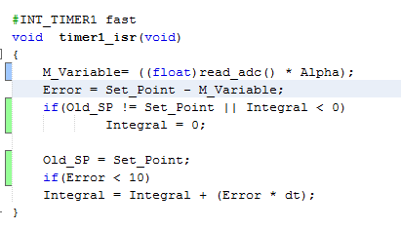

Outside of this interrupt, integrator rests itself for unknown reason.

1. Moved PID calculations out of ADC interrupt. QRD -144

